MED D - Test Claim - Calculating Quantity of Insulin Pens

Definition | Insulin pens may be prefilled and disposable, or refillable (with insulin cartridges). However, most pens are disposable. In both cases, each pen contains a specific mL of insulin. A very short, very thin needle is attached to the pen before a subcutaneous injection is administered.  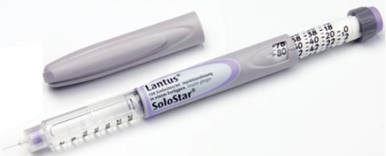
Instructions for Running a Test Claim | What day-supply is needed?  How many units does the beneficiary use each day?  - Clarify depending on the Delivery System selection for the Test Claim as the package size will look different depending on selection of Mail Order and Point of Sale.  - Mail Order only: How many boxes do you use per month?  - Point of Sale only: How many pens are you using?  - Mail Order and Point of Sale: How many boxes do you use per month?  - Useful Tip: Depending on how the prescription is written or how the beneficiary provides the information, when you run the Test Claim, you may need to utilize different fields on the drug details screen to complete calculations:  - Total Pkg Qty: Prescription or beneficiary provides the number of boxes  - Usage Qty Pkg: Prescription or beneficiary provides the units per day  Note:  - If you are unsure what quantity is needed consult with Clinical Care Services.
Common Direction (SIG) Codes | b.i.d. - 2x/day  t.i.d. - 3x/day  q.i.d. - 4x/day  ad - up to  p.r.n. - as needed  qd - every day  qh - every hour  q4h - every 4 hours  q.o.d. - every other day
Additional Notes | - Insulin pens are generally 3ml Penfill Cartridges  - Each brand is different and may not contain the same total of Penfills per box.  - Generally, each bottle of insulin expires 30 days from the date it is first used; therefore, a minimum of 3 bottles for a 90 day supply would be dispensed.  - Refer to the Quick Reference Guide for assistance with Test Claim quantity.
Package Size Difference between Mail Order and Point of Sale | Refer to the following:
Package Size Difference between Mail Order and Point of Sale | Mail Order | Point of Sale | Mail Order & Point of Sale
Package Size Difference between Mail Order and Point of Sale | Package Size: 15 (milliliters) | Package Size: 3 (milliliters) | Package Size: 15 (milliliters)
Package Size Difference between Mail Order and Point of Sale | Package Disclaimer: Yes | Package Disclaimer: No | Package Disclaimer: Yes
Package Size Difference between Mail Order and Point of Sale | This is 1 box of pens. | This is 1 pen. | This is 1 box of pens.
Package Size Difference between Mail Order and Point of Sale | 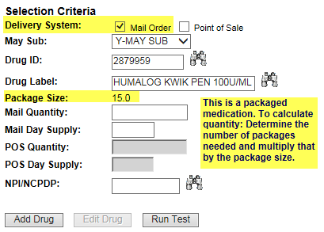 | 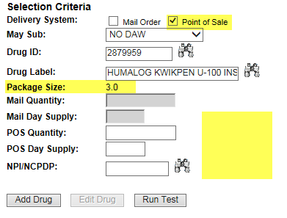 | 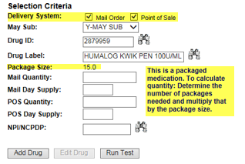
What if Test Claim Rejects | Review the rejection code to determine what caused the rejection. Once the rejection code is identified, access the proper work instruction and job aids in theSource to help you resolve the issue.

Example
Lantus Solostar Pens

Directions: 16 units in the morning, 16 units at lunch and 26 units at night
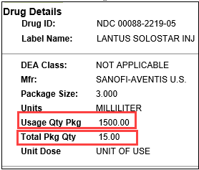 |  |  | 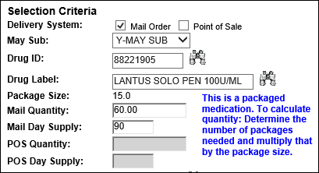
Calculation
Units per Day | X | Days |  | = | Units Needed
58  (16 + 16 + 26) | X | 90 |  | = | 5220
Units Needed | ÷ | Usage Quantity Package  (from PeopleSafe) |  | = | Total Number of Pens
5220 | ÷ | 1500 |  | = | 3.48 (Round up to 4)
Total Number of Pens | X | Total Package Quantity  (from PeopleSafe) |  | = | Test Claim Quantity
4 | X | 15 |  | = | 60

Example
Novolin R Pen

The caller states they would like to order their Novolin Pen through mail order. They’ve advised that they need 4 packages/boxes for 90 Days. The package size is 15, so the CCR would multiple 15x4 and get 60. When they run the test claim the quantity will be 60 and the day supply is 90.

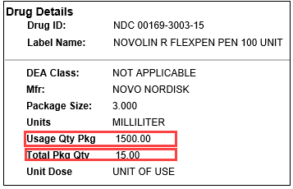 |  |  | 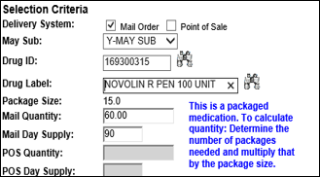
Calculation
Total Number of Packages | X | Total Package Quantity  (from PeopleSafe) |  | = | Test Claim Quantity
4 | X | 15 |  | = | 60

Top of the Document

Quick Reference Guide

Refer to the following tables for a quick reference:
30 Day Supply Quantities for Insulin Pens
How many units per day | Qty (ml) to enter in PeopleSafe) | Boxes Needed
1-16 | 15 | 1
17-33 | 15 | 1
34-50 | 15 | 1
51-66 | 30 | 2
67-83 | 30 | 2
84-100 | 30 | 2
101-116 | 45 | 3
117-133 | 45 | 3
134-150 | 45 | 3

90 Day Supply Quantities for Insulin Pens
How many units per day | Qty (ml) to enter in PeopleSafe) | Boxes Needed
1-16 | 15 | 1
17-33 | 30 | 2
34-50 | 45 | 3
51-66 | 60 | 4
67-83 | 75 | 5
84-100 | 90 | 6
101-116 | 105 | 7
117-133 | 120 | 8
134-150 | 135 | 9

Top of the Document

Related Documents
MED D - Test Claim Index
Calculating Quantities for Packaged Medication

Parent SOP: CALL-0049: Customer Care Internal and External Call Handling
Abbreviations / Definitions: Customer Care Abbreviations, Definitions, and Terms

Top of the Document

Not To Be Reproduced Or Disclosed to Others Without Prior Written Approval
ELECTRONIC DATA = OFFICIAL VERSION – PAPER COPY = INFORMATIONAL ONLY

